**SWARM PLOT**

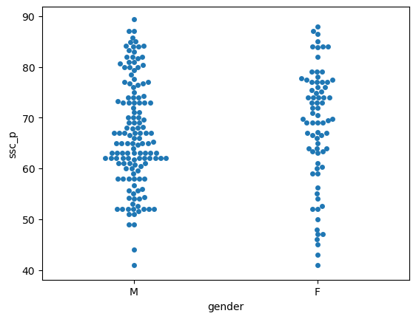

* Top of Form
* Swarmplots are a type of categorical scatter plot its used for visualizing the distribution of data points within different categories.
* They are particularly useful when you want to show the individual data points along with their distribution in a dataset with one or more categorical variables.
* Swarmplot to visualize the relationship between the ‘Gender’ variable and the ‘Ssc_p’ variable in a dataset.
* X=Gender. The ‘Gender’ variable should be plotted on the x-axis. The Gender variable is categorical typically representing two categories male and female.
* Y=Ssc_p. The ‘Ssc_p’ variable should be plotted on the y-axis. The Ssc_p variable is a continuous variable such as a percentage.
* Swarm plot that shows how the Ssc_p varies across different categories of gender in your dataset. Each data point is represented as a point in the swarm plot and the horizontal positioning of the points on the ‘Gender’ axis shows how the Ssc_p values are distributed for each gender category.it can help you visually assess any differences or patterns in secondary education percentages between genders.
* Categories of gender male is higher than female category. Its starts with same level 40% but the end of male achieve 90% and female category achieve below 90%.
* Male candidates average of people achieving the above 50% to 75%. One student was scored 90%.
* Female candidates are most of the people scored from 65% to 80%.